Stewartia at Caerhays

Only three early introductions of Stewartia species to the garden here still survive today and they are all nearing the end of their lives as new replacements take over. It has proved difficult to trace the origins of two of those plants. Ernest Wilson did collect seed of Stewartia sinensis in 1901 and in 1907. Seed was sent to England in the autumn of 1901 (Plantoe Wilsonae Vol II). Stewartia pseudocamellia first came to the Arnold Arboretum of Harvard University in 1918 from Wilson’s collections in Korea. It came to the UK at about the same time. Where the Caerhays plants came from, and exactly when, is sadly obscure. However, the origins of Hartia sinensis (now Stewartia pteropetiolata) are much clearer. George Forrest discovered this plant in 1912 and gain in 1924 at an altitude of 8-9,000ft when he stated it was ‘a very interesting shrub, the leaves being used for tea locally’. He later thought it might be a gardenia. Forrest’s collector’s number was 24406 and J C Williams notes record ‘ten good plants growing at Caerhays and one planted at Werrington’ in around 1930. The one surviving, mature, Caerhays plant today was formerly a clump of three below Pound Corner.

What we can do with more certainty is to list the sizes of the three original Caerhays plants as they were measured over the decades:

Stewartia species | Measured by | Year | Height | Girth (3ft from base)
S. pteropetiolata | Alan Mitchell | 1971 | 56ft | 4ft2’’
 | Owen Johnson | 2006 | 33ft | Top of the tree had died back
 | Owen Johnson | 2016 | 23ft | 6ft (Champion tree UK and Ireland by girth)
S. sinensis  (S. gemmata) | Alan Mitchell | 1964 | 37ft | 1ft11’’
 | Alan Mitchell | 1971 | 39ft | 2ft1’’
 | Owen Johnson | 2006 | 43ft | 3ft7’’
 | Owen Johnson | 2016 | 39.37ft (Champion tree Cornwall by height) | 4ft6’’
S. pseudocamellia | Owen Johnson | 2006 | 26ft | 2ft3’’
 | Owen Johnson | 2016 | 26ft | 2ft9’’

Stewartia pteropetiolata (formerly known as Hartia sinensis) is the only evergreen species of Stewartia growing at Caerhays. The tree has a straight, upright habit and is very vigorous when established. The side branches are slightly cascading and droop down from the erect main stem. The new growth emerges early in the spring with an attractive reddish hue at first before turning light then darker green. The flowers appear in May or June (7-9cm) wide and make an impressive display over several weeks at the end of the spring season. Our younger plants produce copious amounts of greenish seed heads which turn brown, then black, when ripe in October and, after bursting, often remain afterwards on the tree well into the next spring. Many Stewartia species are best known for their attractive peeling, splitting or shedding bark in winter and spring but this is not the case with S. pteropetiolata. It is slightly fissured but otherwise unremarkable.

Despite the huge amount of seed produced by the several younger trees here we have found that it is very difficult to achieve germination from them. Some species of Stewartia are said to take up to four years to germinate and this may well be the reason. Thankfully, this very rare plant can be propagated relatively easily from softer new growth cuttings taken in June/July or, alternatively, from more conventional evergreen cuttings taken in October/November. As a result this plant no longer deserves to be rare and unrepresented in gardens. Cornwall Garden Society members are welcome to cutting or seed material on request to help get this wonderful plant more widely distributed and grown.

The latest references to this species in ‘New Trees’ state that S. pteropetiolata grows in Chinese forests at an altitude of 1,200-1,600ft. It may therefore be viewed as being too tender for growing outside the mildest areas of the UK. However, our experience has been somewhat different, probably since our plants come from a collection at a much higher altitude. The very cold winter of 1963 did not damage the original plant which eventually lost its top 20-30ft in the 1990 hurricane. Thereafter it produced new shoots from the base of the trunk and became multi-stemmed. The reference books say that -5° may be its limit but this has not been the case here. One 15 to 20 year old plant grows very happily in the teeth of westerly gales beyond the lake where its leaves often get severe scorching from salt winds but it soon recovers when the new growth emerges.

It is indicative of its rarity that S. pteropetiolata gets scant mention in the excellent article on stewartia in The Plantsman (2008).

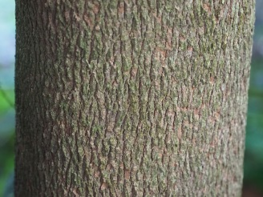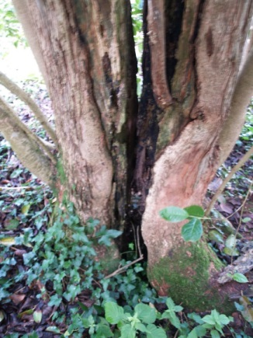
S. pteropetiolata bark and new shoots from the base replace the original trunk

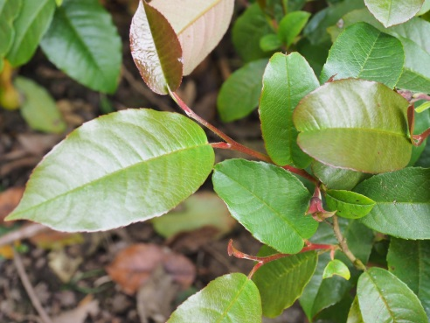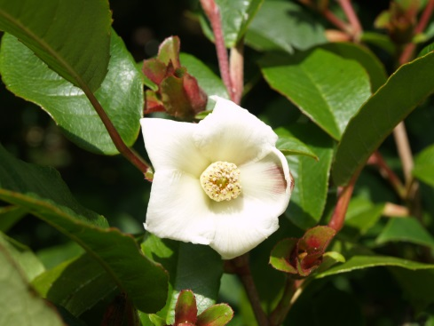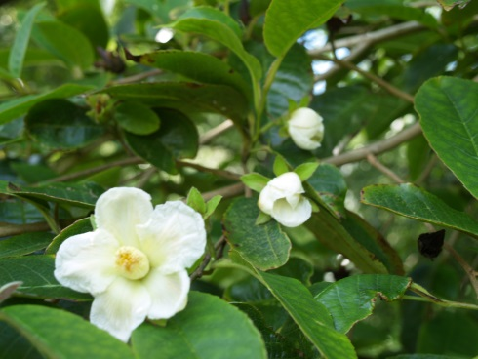
S. pteropetiolata new growth and flowers

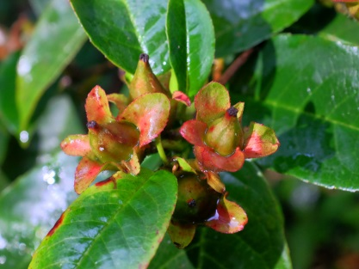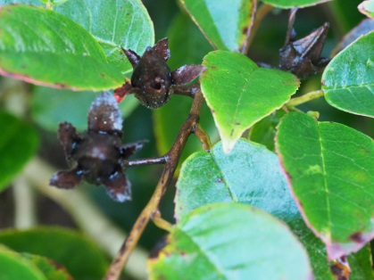
S. pteropetiolata seed pods

Stewartia sinensis (S. gemmata) grows here on Burns Bank above Quarry Path where it is leaning at an angle which will soon result in disaster. Over the decades there has been much argument about the identification of this tree and one has to review the appearance of the bark at different times of the year to begin to come to a definite conclusion.

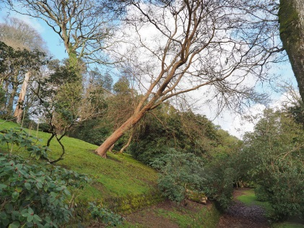
S. sinensis hanging over pathway

In early winter the bark peels from the base of the trunk and, progressively, upwards. In spring and early summer there is evidence of splitting and exfoliating which makes for the confusion with S. monodelpha, and even perhaps S. pseudocamellia, at certain times of the year which also have this habit. Over the years various experts have given our tree all these three different names.

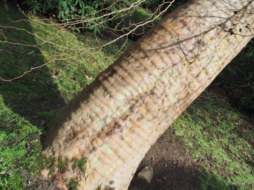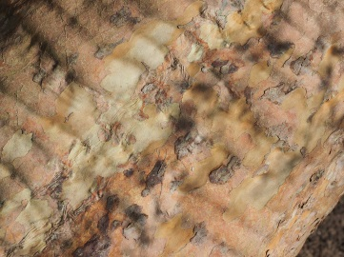
S. sinensis bark in winter

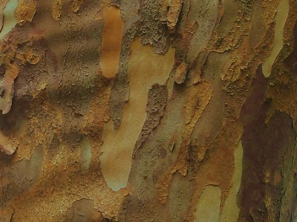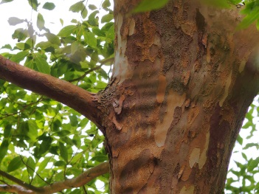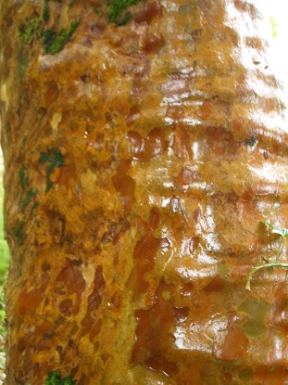
S. sinensis bark in summer

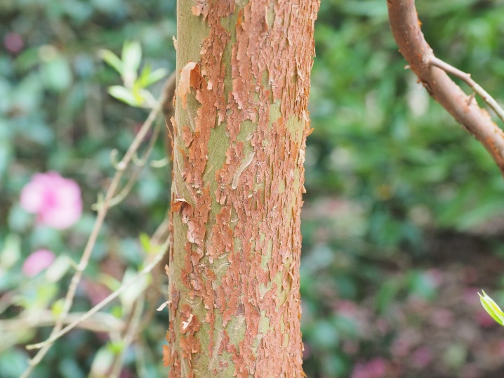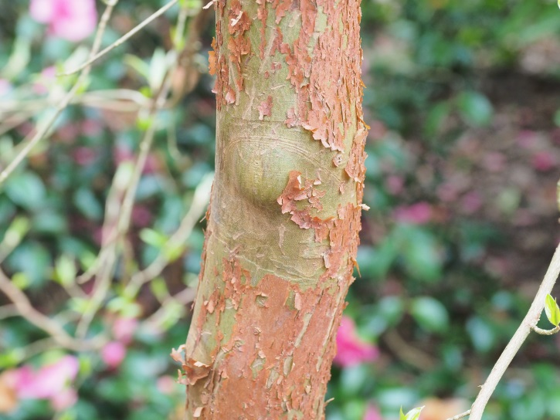
S. sinensis peeling bark in a young tree

It is however the flowers which hold the key to identification. Stewartia sinensis has small (5-6cm wide) flowers in profusion which do not all open fully. The five floral bracts are ovate and much the same size as the sepals. You can see this very clearly just before the flowers open. The seed capsules are conical and hairy over the entire surface although one has to look very closely to establish this.

We have collected, or tried to collect, the plentiful seeds from this tree for many years. Such is the profusion of seed capsules that most, if not all, of those collected in recent years were completely sterile. Perhaps the tree is simply too old and exhausted to produce fertile seeds? Anyway our attempts have so far produced nothing so we have resorted to planting new specimens imported from Holland via Burncoose Nurseries. At a young age, and with no adult bark, it is still far from clear from the early flowers if these new additions are indeed S. sinensis.

The reference books make clear that this is, however, a very variable species with 4 separate forms identified in the Flora of China. Our plant does not have anything like as much peeling bark as the record S. sinensis at Trewithen nor does it have the smooth or deeply mottled bark of S. sinensis pictured recently on horticultural websites of plants growing in US or Belgian arboretums.

The plant as Caerhays hangs over a pathway so that you can look up and admire the inflorescence usually, here, in late June or early July. Unlike several other species, all the flowers appear and drop at the same time. An impressive plant which, like most Styrax species, is best grown where you can view it properly on a slope from below.

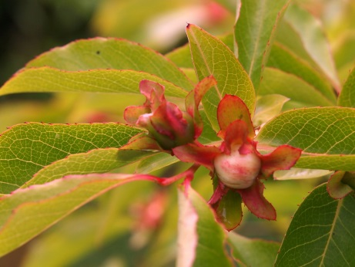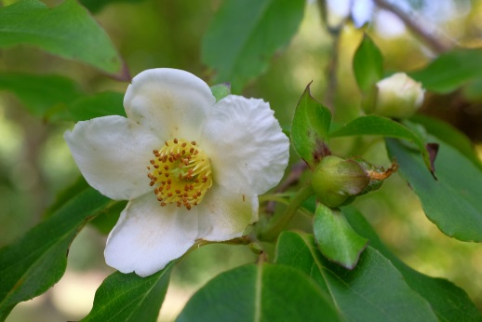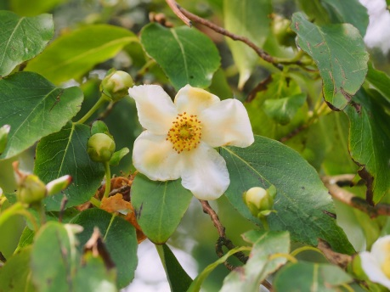
S. sinensis floral bracts and flowers

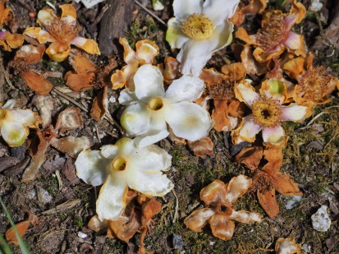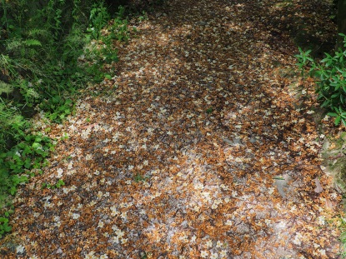
S. sinensis flowers on ground

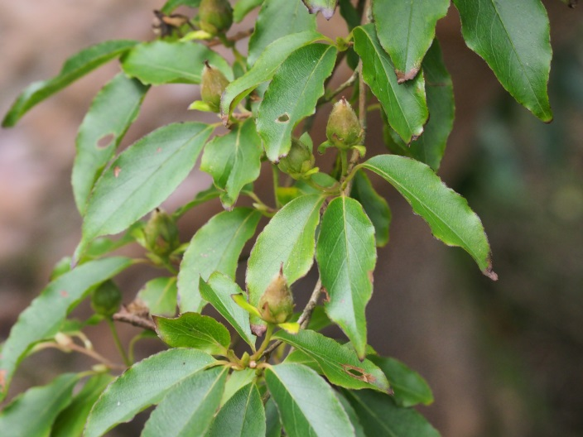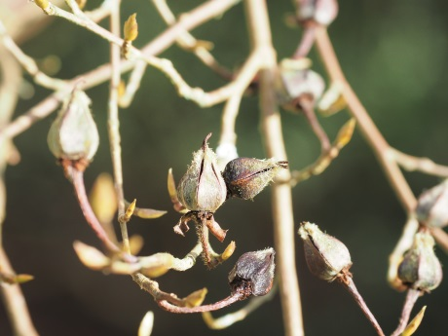
S. sinensis seed when first formed and seeds in winter

Stewartia pseudocamellia is far and away the most widely grown of this genus of plants and deservedly so. It is of Korean and Japanese origin and is usually ranked as the best in the genus for its ornamental bark and often then, also, for its autumn colour.

Our original plant had three separate trunks of which one has recently died while the other two are usefully establishing new and vigorous shoots from near the base of the old trunk now that proper light reaches down to the ground. This is a feature which Stewartia seem to share with most Styrax species as they mature into old age.

In spring the greenish bark splits or exfoliates irregularly over several months to reveal mottled patches of yellow or white which eventually fade to different shades of grey-brown or brown as the seasons progress. The pace and scale of bark splitting can, and does, vary over the years and these photographs may well not do full justice to all the changes which occur in our elderly plant.

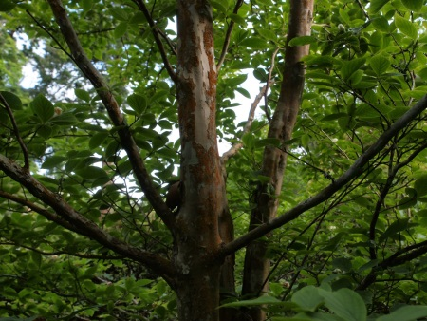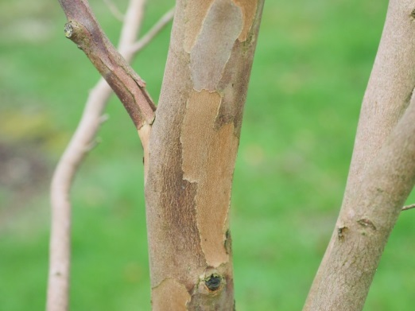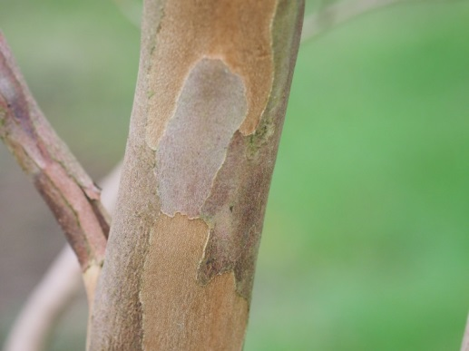
S. pseudocamellia bark on a mature tree

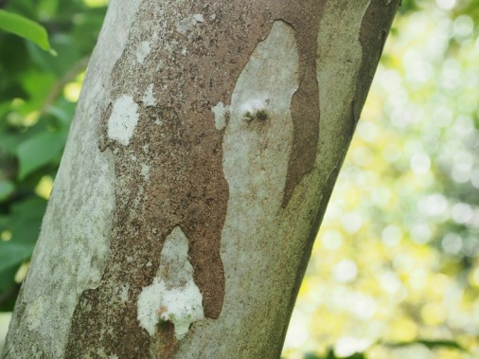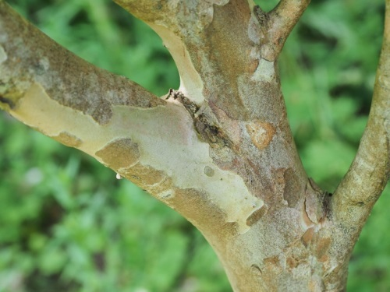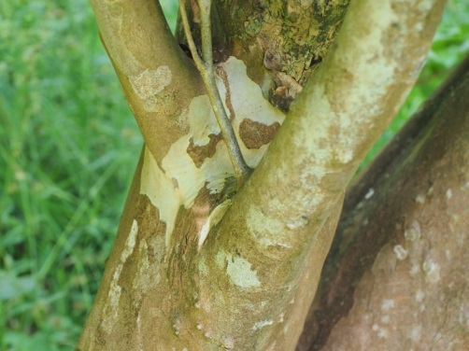
S. pseudocamellia bark on a mature tree (continued)

Stewartia pseudocamellia Koreana Group has somewhat different bark and flakes in a different way. These pictures are of the bark on a 25 to 30 year old plant. This form of S. pseudocamellia is said to have the best autumn colour and this is beginning to become the case.

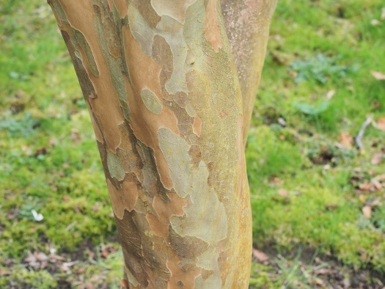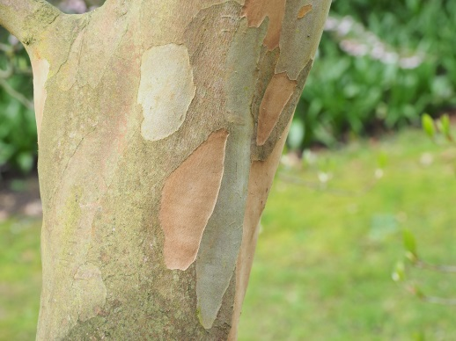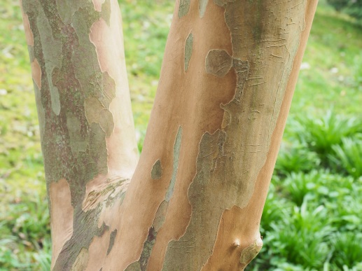
The bark on a young S. pseudocamellia Koreana Group

Unlike the two species mentioned above our Stewartia pseudocamellia is no longer ‘plastered in flower’ as the reference books describe. Its flowering is irregular and sparse with some younger shoots and twigs having no flowers at all. The large 9-10cam wide flowers appear in mid June and open flat with 5 petals. Some flowers have green blotches. The few greenish seed heads which follow have 5 rounded sepals and, by mid autumn, turn back and split into split into 5 sections. The young growth of S. pseudocamellia has a strange zig-zag habit. Softwood cuttings are fairly easy to root in June/July although great care has to be taken over winter to ensure their survival and regrowth in the spring. Limited survival rates are quite normal, as with many softwood cuttings from that type of small tree. This, for us, has however been an easier means of propagation than trying to grow the seeds.

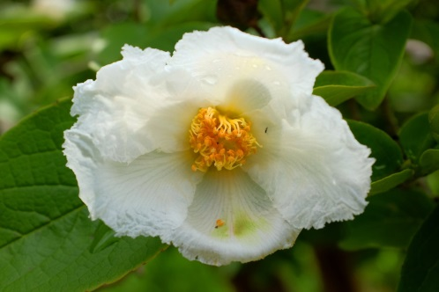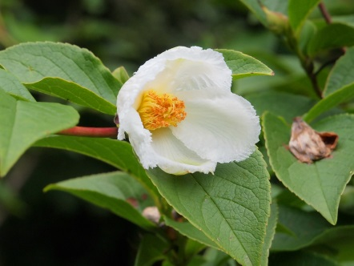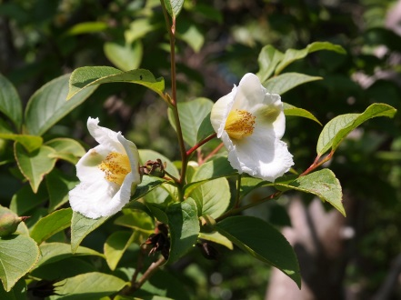
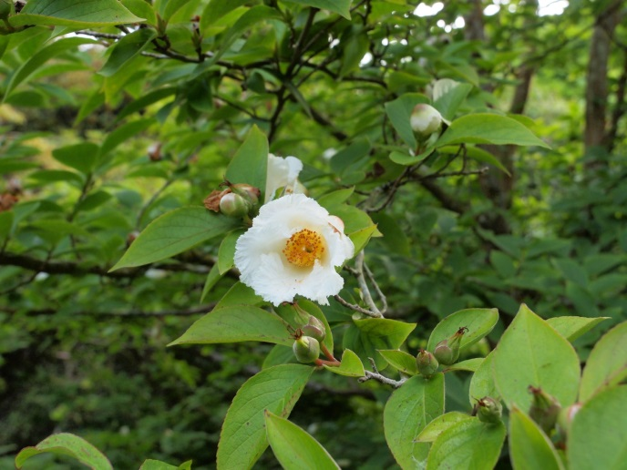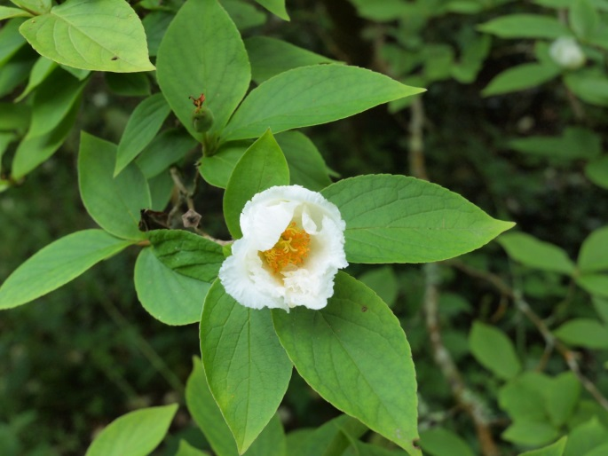
S. pseudocamellia flowers

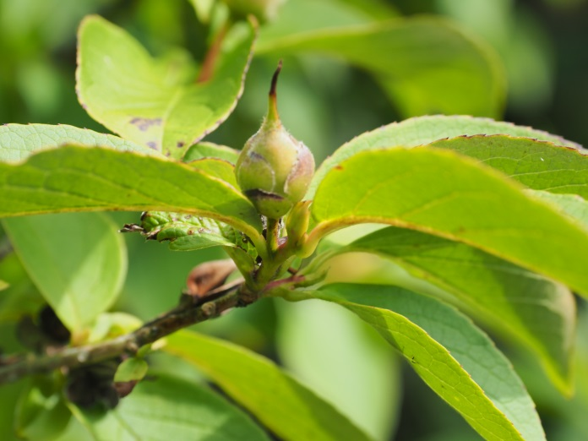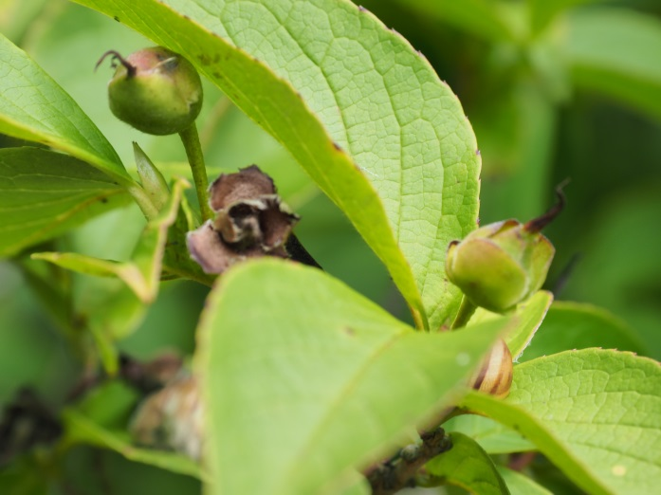
S. pseudocamellia seeds

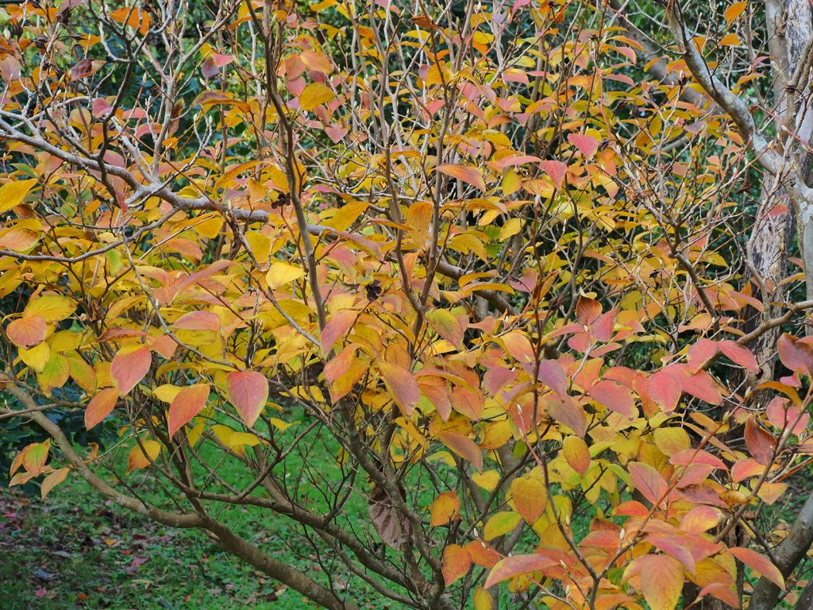
S. pseudocamellia with autumn colour

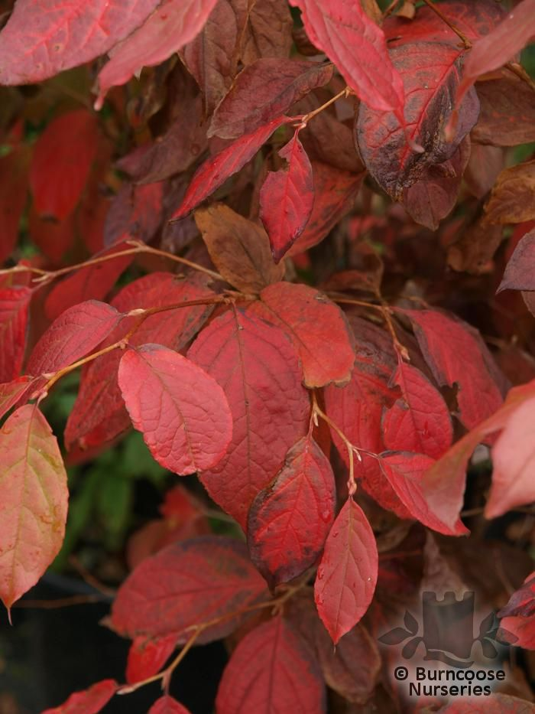
S. pseudocamellia Koreana Group

If gardeners with space to fill are tempted to stick with the proven excellent of S. pseudocamellia they might just like to reconsider after an assessment of the newer species of Stewartia now growing here. One in particular appears to us to have even greater garden merit.

When I first read Philippe de Spoelberch and Koen Camelbecke’s definitive pictorial article on how to identify Stewartia species in 2011, largely from their collection at Arboretum Wespelaar in Belgium, I was immediately struck by how much better Stewartia rostrata was performing here at Caerhays in comparison to the pictures shown in this article or indeed in the 2008 article in The Plantsman on Stewartia. Koen was kind enough to enter into correspondence but it may be easier for pictures of the plants performing here to make the case.

There are three plants of Stewartia rostrata growing here which were planted between 1999 and 2002 in different locations varying from full sun in an exposed location to nearly full shade under a Scots Pine in an extremely sheltered one.

The bark may indeed be nothing to write home about but the flowers and the autumn foliage colour beat all other species by a length in our estimation.

Stewartia rostrata is one of the very first species to flower in late May and has occasionally made it onto the Burncoose stands at the Chelsea Flower Show. The reference books maintain that the flowers are 3-5cms in diameter but, as these pictures show, this is something of an understatement. The other thing that has been underestimated is the extent of the attractive pink blotches on the flower buds which creep over onto the inside of the petals as they first open. Since not all the flowers open at the same time, there is much pink to admire alongside the white. It is also said that S. rostrata can be reluctant or slow to flower until the age of 15 or so but we have found that 2-3 foot tall young plants in the nursery are covered in flower. Clearly we started with a good clone which originated from Mark Bulk’s nursery in Holland some 28 years ago

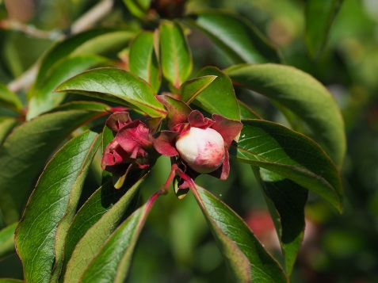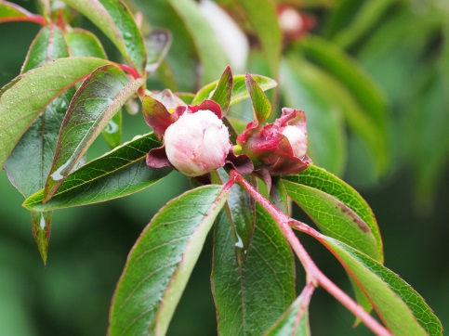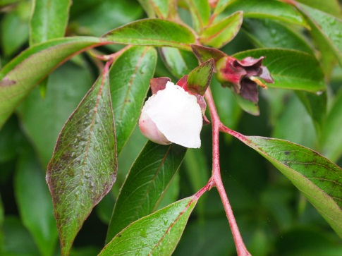
S. rostrata buds

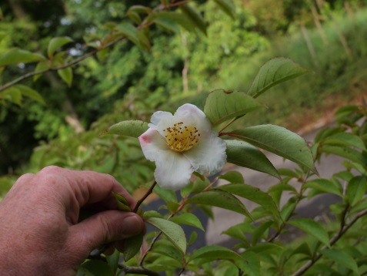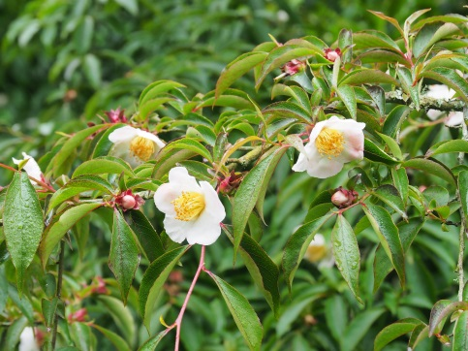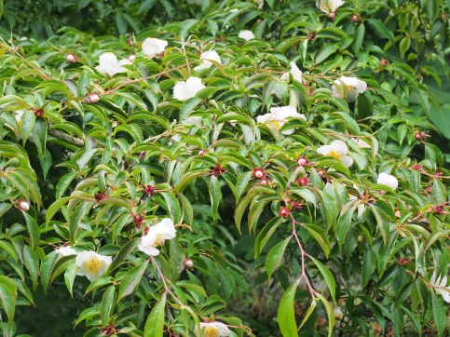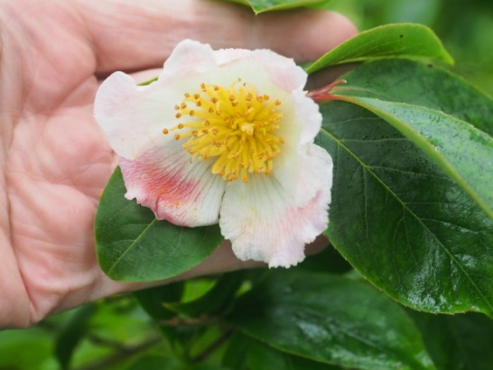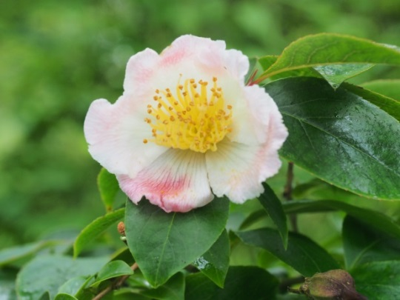
S. rostrata flowers

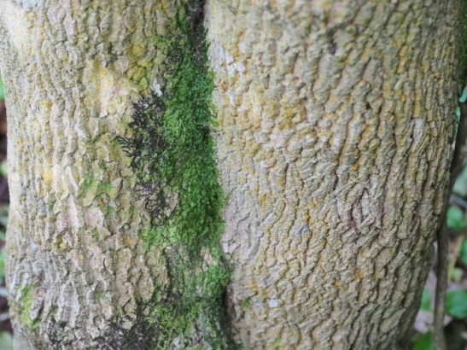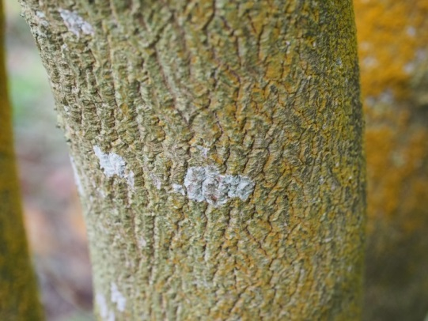
S. rostrata bark

S. rostrata has large and impressive seed pods which stand proud to the stems and twigs and turn reddish as autumn arrives, but well before any changes in leaf colour. The sepals which surround the seed head are attractively twisted. They eventually turn black and split into 5 sections. Arguably the most pronounced and attractive of all stewartia seed pods, S. rostrata, is the easiest of all species, we think, to propagate from soft wood cuttings taken from immature but established trees.

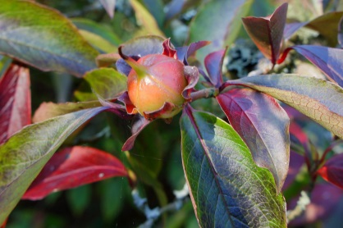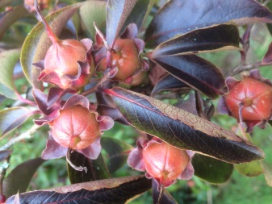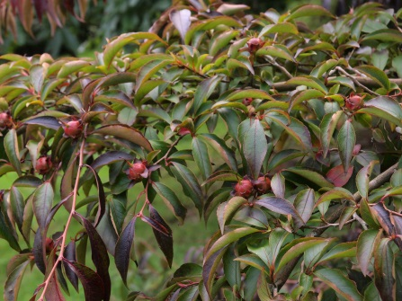
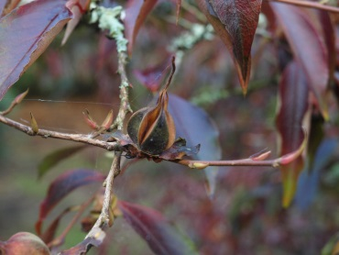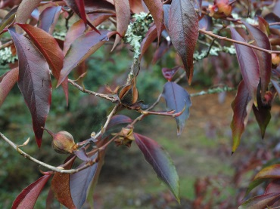
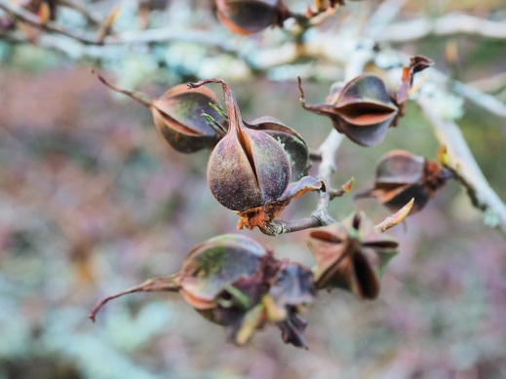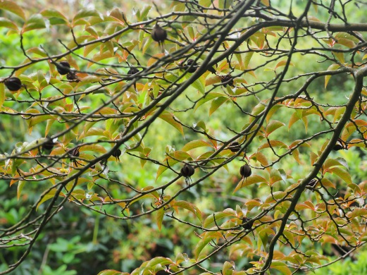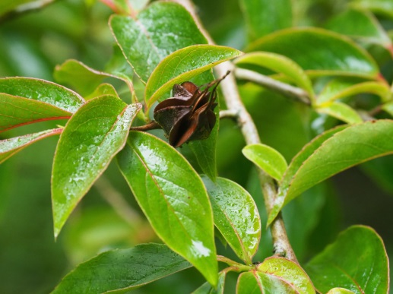
S. rostrata seeds

The story does not end here. With us the autumn colour is superb. Cornwall’s westerly gales normally mean that good autumn colour is an occasional, passing, and short lived surprise. However S. rostrata produces a display which seems impervious to gales or mild conditions in the autumn. Quite the best red, turning almost black, autumn colours on the main drive at Caerhays emanate from the S. rostrata growing in full sun. The plant in full shade colours later with more red than black, confirming our mistake with its original location.

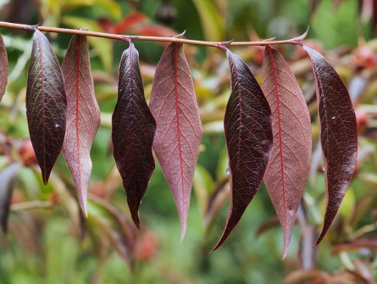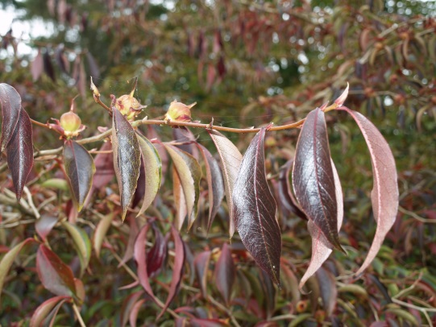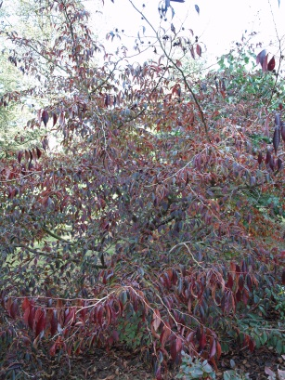
S. rostrata autumn colour

It is pretty clear that Stewartia rostrata is just as lovely as S. pseudocamellia and therefore suitable for growing in all UK gardens. Strangely, and somewhat absurdly when you look, the species was only first introduced from China to the USA in 1936 and was considered a distinct form of S. sinensis until 1974!

Next on the list of new Stewartia species to try yourself should be Stewartia x henryae. This was first discovered as a spontaneous cross between S. monodelpha and S. pseudocamellia in Pennsylvania in 1964. The flowers on our two smallish young plants are not that exciting but the brilliant red autumn colour certainly is. One plant is right in the open on the new 2007 10 acre planning in Kennel Close. The long lasting autumn colour stands out at 100 yards and lasts on well as other leaves fall.

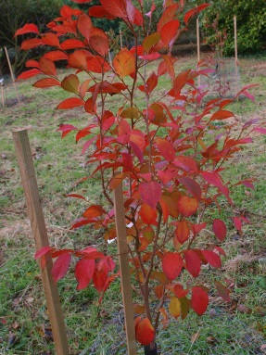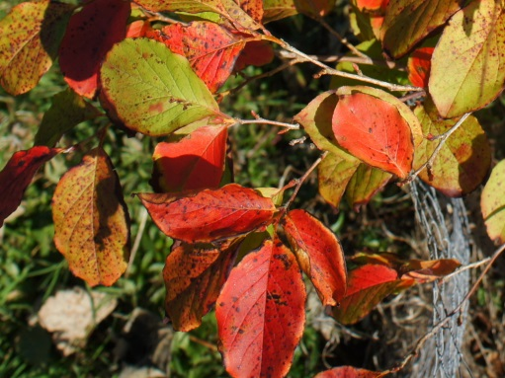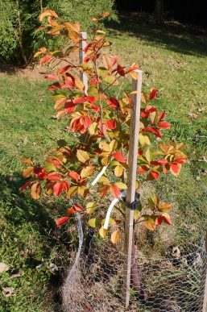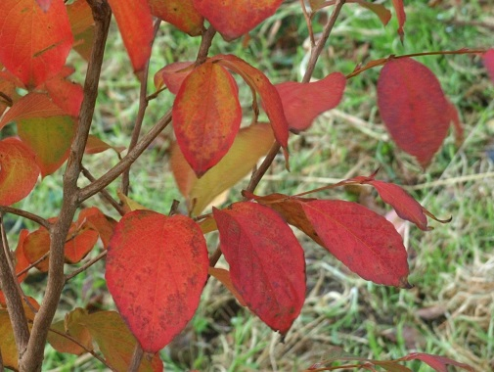
S. x henryae autumn colour

Newish to our Stewartia species collection and some with their first flowers and autumn colours are:

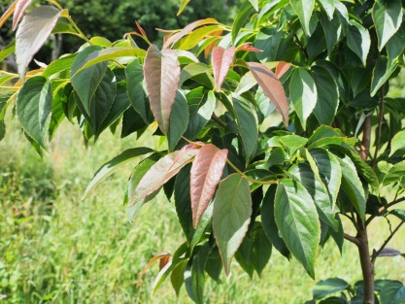
S. monodelpha leaf form

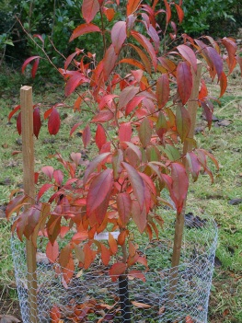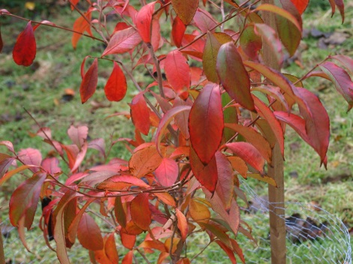
S. monodelpha autumn colour

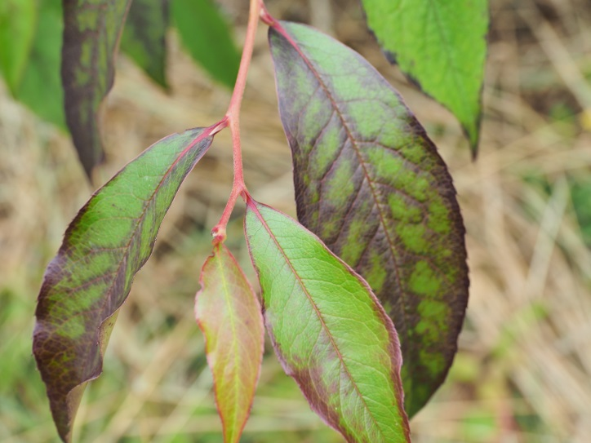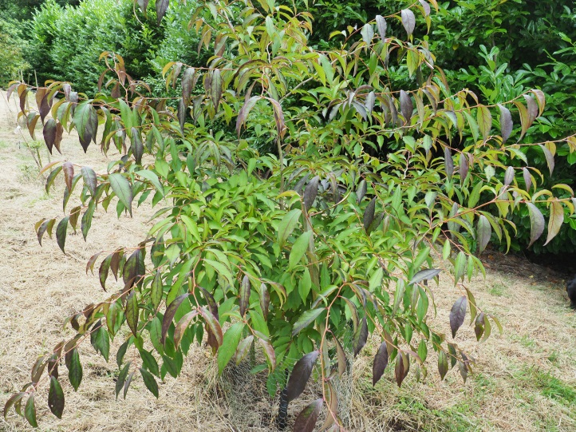
S. malacodendron

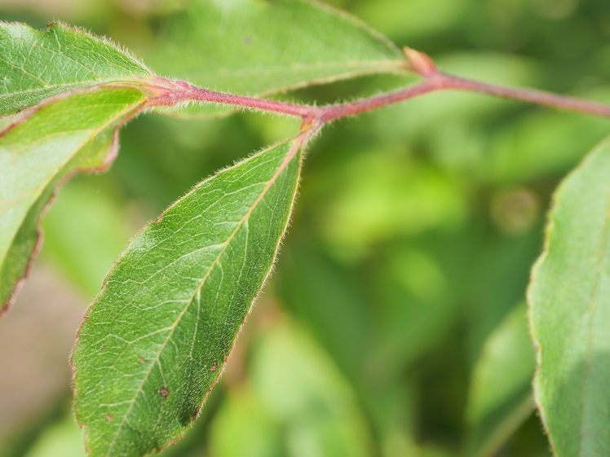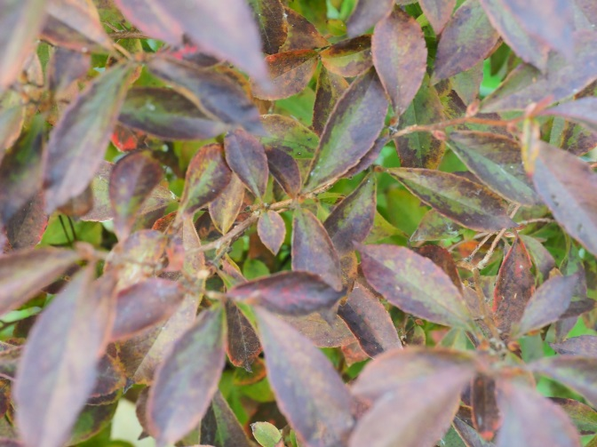
S. serrata

We have been placing these new species within and alongside plantings from 2002 of Styrax species in particular parts of the garden which come into their own in June when so much else is over. We have yet to attempt some of the names Stewartia clones or selections but this is for the future.

Stewartia come from the Theaceae (or tea) family which all have single white flowers. Their affiliation with camellia and franklinia is therefore obvious. In the wild they are widely spread from Japan, Korea, Vietnam and Southern China as well as the south eastern United States. Opinions differ on the number of species which exist in the wild but these currently range from between 20 and 25. Of the 15 species from China only perhaps four are currently in cultivation and the rest are thought to be too tender for our climate (Tom Hudson is now growing S. villosa but it has yet to flower). However, our experience with S. pteropetiolata here, would suggest that two other evergreen Chinese species, S. calcicola and S. laotica, may well be worth a try if they do ever get introduced into the UK. In the meantime we will continue to enjoy the 8 or 9 species which are now growing here with S. rostrata as our first choice.

Charles Williams, VMH
August 2018

(Further cultural advice on propagating and growing Stewartia can be found on the Burncoose Nurseries website: www.burncoose.co.uk)

Species | Origin | Date introduced
S. x henryae | Pennsylvania | 1964
S. malacodendron | SE USA | Circa 1742
S. monodelpha | South Korea | Circa 1903
S. ovata | SE USA | Pre 1785
S. pseudocamellia | Japan and Korea | Before 1878
S. pteropetiolata | Yunnan, China | 1912
S. rostrata | China | 1936 (to USA)
S. serrata | Japan | Pre 1915
S. sinensis | Central China | 1901

