Caerhays Castle Gardens and Climate Change

What does the Caerhays Garden Diary (1897-Today) tells us about ‘Climate Change’?

(The Garden Diary records events with each day of the year showing on just one page for ease of reference. It was written by JC Williams until 1939, Rt Hon Charles Williams until 1955 and Julian Williams until around 2010. More recently Charles Williams has continued the daily diary online with photographs on each day. The whole diary can be accessed online at http://thediary.caerhays.co.uk/.)
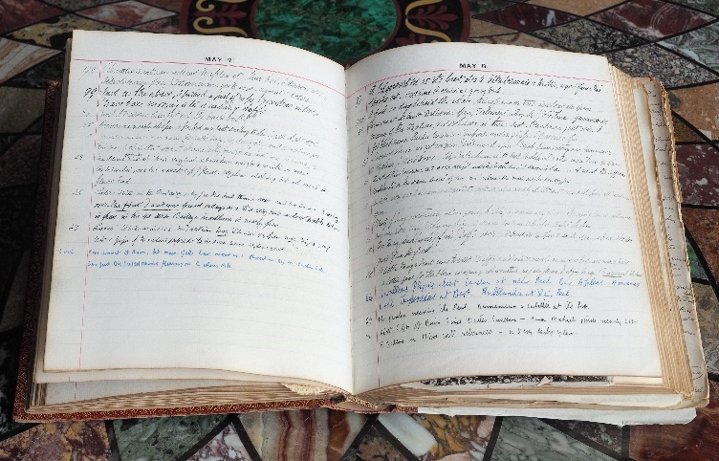

We now live in a world where ‘climate change’ is an accepted reality by the vast majority of the population. Even without Greta Thunberg or Extinction Rebellion the political class clearly do believe that our climate will warm (or has already warmed) by 2% (2% of what?) in the coming decades. This has produced the mass hysteria which led to the Paris Climate Accord following which the UK government has stated, as a legal objective, that we must become carbon neutral by 2050 or earlier or else! A whole industry has grown up around supposedly green energy with all the vested interests therein. Greta may well be a Scandinavian PR creation for just that purpose, as a few serious journalists have attempted to point out, before being shouted down in the adulation. Carbon credits for Elton John’s air flights for our royal family members can readily be bought to ease consciences but already the scandal of such ‘credits’ is now being exposed in ‘The Times’ newspaper.

In such a topsy turvy vacuum, driven by hysteria, we must all be seen to be doing the ‘right thing’. Let us pause a moment and put political (climate) correctness to one side. What do 123 years of the Caerhays Garden Diary tell us about climate, global warming and how plants have reacted to extremes of weather over the years? Is ‘change’ already evident and provable, or is it something which still may or may not actually happen from a historical perspective?

The Royal Horticultural Society warns and advises us today to prepare our gardens for major change in the types of plants we should grow with lower rainfall, droughts, and warmer temperatures. Vineyards in the south of England are a growing reality. South African drought resistant plants have seen a surge in popularity and Mediterranean grown plants have been imported piecemeal into our garden centres in the last 20 years as we prepare to welcome our drier and warmer climate. New Zealand tree ferns are for sale in supermarkets and the surge in demand for (imported) house plants is another feature of the changing mood amongst gardeners. The implication is that we may no longer be able to grow some of the Asiatic rhododendrons and other ericaceous plants imported from China around 100 years ago as a result of the work of the great plant hunters.

Climate Change implies drought. How have the average rainfall figures for Cornwall changed over the decades and how much drought does The Garden Diary reveal over the decades?

Average rainfall (per year) | 1900-1920 | 42.12in
 | 1921-1940 | 35.4in
 | 1941-1960 | 37.8in
 | 1961-1980 | 44.4in
 | 1980-2000 | 43.08in
 | 2001-2005 | 38.64in
 | 2006-2010 | 39.48n
 | 2011-2015 | 43.32in
 | 2016-2019 | 45.36in

These are average figures for Cornwall as, sadly, no long term rainfall records exist specifically for Caerhays. It is certainly likely that the rainfall here at Caerhays, on the south Cornish coastline, was actually higher than these figures.

The rhododendrons, camellias, magnolias and so many other species of Chinese plants which Ernest Wilson (1876-1930) and George Forrest (1873-1932) introduced to Caerhays and other UK gardens originated from mountain forests altitudes far higher above sea levels than those where they now grow in the UK, and with colder winters than we normally see in Cornwall. Mountain forests are often shrouded in cloud and have high levels of rainfall.

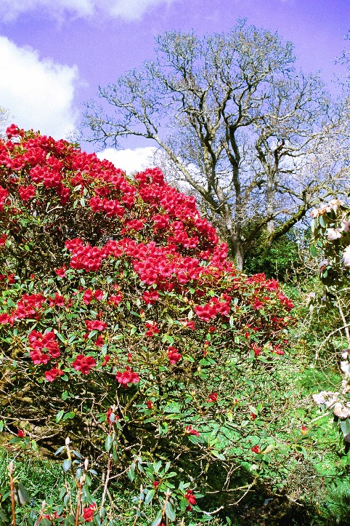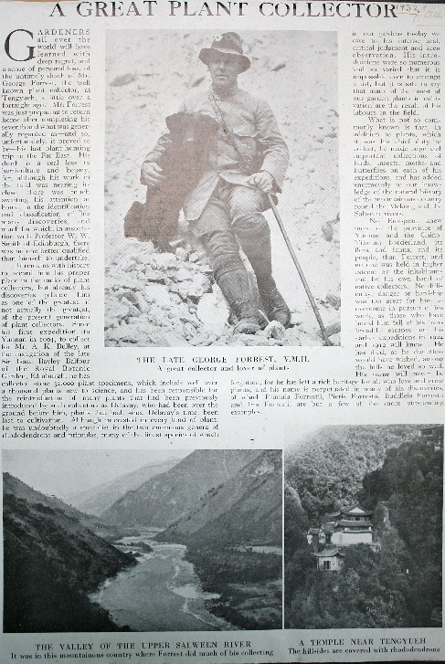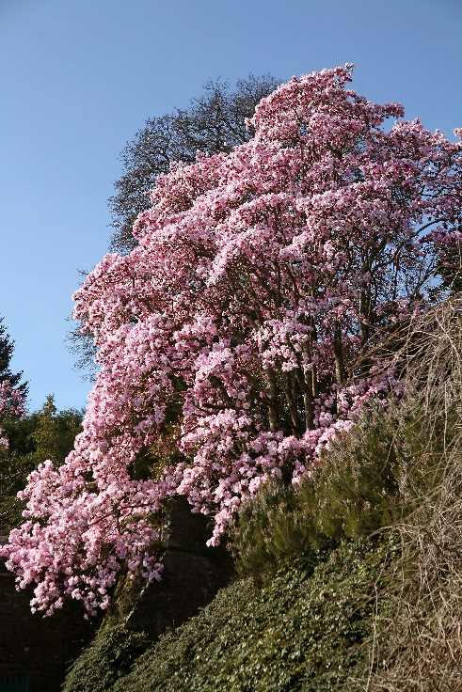

In the last two summers we have supposedly had droughts, although the rainfall in Cornwall was 47.15in in 2018 and 49.56in in 2019. The worst drought in my own living memory was in 1976. Then the last major rain fell in the last week of April and there was virtually no rain at Caerhays until September. The grain harvest was complete by 10th August, beech trees had 20ft of dieback in their crowns and the more mature big leafed rhododendrons (Rh. sinogrande and Rh. macabeanum especially) were killed piecemeal throughout Cornwall. It took us 30 years at Caerhays to grow on similar sized specimens. When the woodland gardens were first laid out here between 1905 and 1920 there was a system of lead pipework through the garden with regular standpipes to cope with dry summers. The Garden Diary records these being used in the gardens by the vast team of 60 gardeners who worked here before the Great War. The watering system was progressively destroyed by felling trees and ceased to function by the 1960s. Aside from 1976 it has not been necessary. Hand watering of only newly planted plants has sufficed since.

So ‘climate change’ has not reduced rainfall levels in Cornwall or at Caerhays in the last 120 years. We can now, arguably, demonstrate that rainfall levels have actually increased in recent years which is clearly beneficial for the Asiatic plants which we grow. Occasional dry summers do not necessarily mean droughts providing we get a couple days rain each summer month or periods of drizzle and sea-fret which mimic Chinese mountainside conditions.

With droughts one would then expect climate change to bring milder winters with less frost, snow and ice. Climate change believers are often confused at this point because they attribute both winter flooding as well as extreme cold weather to climate change when the logic would be that it should be one or the other but probably not both. The Met Office now giving impending storms actual girls and boys names has added to the concept of extremes of weather and ‘change’.

The Garden Diary makes frequent mention of severe cold and snow. Here are a few quoted examples over the last century which occurred at the start or end of the year and therefore delayed flowering times as well as killing more tender plants and destroying those flowers which were already out:

5th December 1925 | The east wind has gone on for some time, pond frozen over.
5th January 1941 | Pond half frozen and ice in buckets 3in thick
9th January 1982 | Blandford’s garden had 3ft of snow
12th January 1987 | The coldest day I have seen 10° of frost at 10am and 18° of frost at 10pm
16th January 1985 | 5°C – 24 hours of snow and pond frozen over – wildfowl shooting forbidden – cut off here
20th January 1963 | Heaviest fall of snow to date. We have now had three weeks of very cold weather. Garden barren of flower. (4th February 1963 – third fall of snow for the winter) (17th February 1963 – a remarkably lengthy time of cold in an absurdly late year)
26th January 1940 | This frost harder than in December. 1938 – all fuchsia out, geranium probably dead. Camellia saluenensis coming out again but no colour on any rhodos.
30th January 1947 | Heavy snow, Church Hill blocked. I stayed in London as transport impossible.
12th February 1954 | Three inches of snow and 16° of frost for a week
23rd February 1955 | Nine to ten inches of snow on lawn. Church Hill drifts still 3ft deep on March 12th.

The prevailing ‘wisdom’ is that recent Cornish winters are getting milder but anyone who experienced ‘the Beast from the East’ in March 2018 might reasonably disagree! At Caerhays we had two deluges of snow, the first of which remained with us for over a week, amid sub-zero temperatures and a biting east wind. This defoliated evergreens to present us with carpets of green leaves on the garden paths and a high casualty rate among more tender species which could not tolerate temperatures this low for such a long period. March 2012 was rather similar when, again, the magnolia flowering season was reduced to brown mush by east wind and frost. Not a great advert for the Magnolia Society International who visited us then.

The historical evidence of cold winters in the Garden Diary shows them to be both irregular and fairly uncommon. 1947 and 1963 were exceptionally cold and the casualty rate amongst plants was considerable. The weight of snow snapping branches was probably as bad as the dieback and demise of feature plants. Even today the large Magnolia doltsopa bear the scars of their complete pollarding after the six to eight week February to March freeze up in 1963. Thankfully, they made a full recovery then, as they did after a total defoliation in ‘the Beast’.

The diary gives no indication that snow and ice are simply a thing of the past and never to be repeated. That would be a rather absurd presumption as history shows.

Then we come to the argument that springs are becoming earlier and earlier due to climate change. The National Trust are especially keen on this with their flowering plant counts in their gardens in February. These are naturally an incentive for visitors to go to their gardens rather earlier in the year. The newspapers lap all this up with attractive pictures of children frolicking with magnolias, daffodils and camellias and so the myth, or supposed reality, is perpetuated.

Let us take one good example: The timing of the flowering of Magnolia campbellii, mollicomata and sargentiana var. robusta over the years. These wonderful, newly introduced, Asiatic tree magnolias were first shown at an RHS Vincent Square show in 1918 and were thereafter much in demand. They did however take 15 to 20 years to produce flowers so they do not feature much in the Garden Diary until the 1950s.

17th January 2005 | First flowers on M. ‘Bishop Peter’
21st January 2019 | Magnolia ‘Todds Fortyniner’ now fully out after showing colour by Christmas Day.
22nd January 1954 | First M. campbellii full out
24th January 2018 | First colour on Magnolia ‘Todds Fortyniner’ above the greenhouse. Not quite the first out this year unlike the last two years.
26th January 1995 | First flower on M. ‘Bishop Peter’
26th January 2020 | Magnolia ‘Todd’s Forty Niner’ is finally showing colour.
27th January 1975 | Philip picked first M. mollicomata cross by steep steps [‘Caerhays Belle’]
28th January 1994 | First flower M. molli x robusta hybrid near back yard
29th January 2019 | The two magnolias through the arch continue to come out despite the coldish snap and some northerly gales with heavy rain. Ridiculously and worryingly early.
30th January 1898 | Magnolia halleanna open flower (now M. stellata)
31st January 1989 | First flower on M. ‘Bishop Peter’
2nd February 2017 | Second magnolia for the year is beginning to be out. Again it is the old original and rather poor near white Magnolia campbellii near Tin Garden.  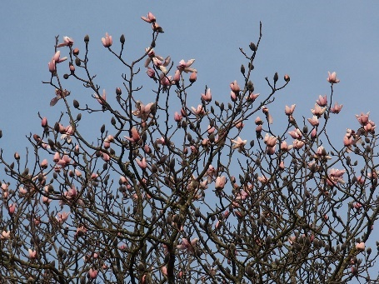
3rd February 1990 | A first flower on the original Magnolia sprengeri ‘Diva’ and M. ‘Bishop Peter’ shows colour
3rd February 2005 | Magnolias in flower can be seen from the front door
4th February 1994 | First flower on M. ‘Bishop Peter’
4th February 2016 | The true Magnolia ‘Lanarth’ planted in 1955 and now flowering for only the third time (this time properly) is out. Slightly paler than I would expect due to it being out two months early and slightly windblown to boot.
8th February 1999 | Four flowers on M. ‘Bishop Peter’
8th February 2015 | Magnolia campbellii ‘Strybing White’ showing colour but frosted. Also coming out by Lodge at Burncoose. A poor New Zealand bred plant with a smallish flower but it is usually the first magnolia to show colour.  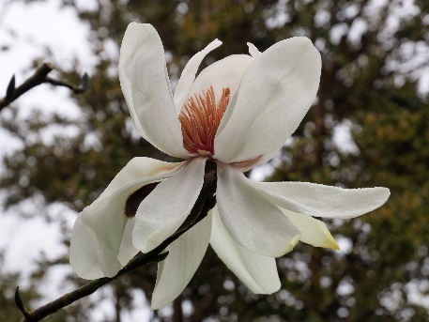
9th February 2015 | Magnolia sprengeri var elongata blown open but frosted by Tin Garden.
10th February 1998 | Jaimie picked first magnolia flower in Tin Garden
11th February 2015 | Found a tail end flower on Magnolia grandiflora ‘Edith Bogue’ Jaimie says it’s ‘Symmes Select’. Is this a record for lateness in the wrong season? First colour showing on record Magnolia campbellii on main path. Should be out in full by end of month if no frost or east winds.
12th February 1962 | One flower out on George’s campbellii
12th February 2002 | First magnolia flower – hybrid closest to Auklandii Garden
13th February 1943 | One flower fully out on Mag. sargentiana also several campbellii
14th February 2001 | Giddle Orchard magnolia showing colour
15th February 1948 | Flowers on Mag. sargentiana robusta but no others
15th February 2000 | Giddle magnolia has several flowers
15th February 2001 | Back yard magnolia showing colour
16th February 1946 | Both Magnolia campbellii have a few flowers out
16th February 1988 | Seven magnolias out including Giddle, Bishop Peter, two by steps and two by Crinodendron hedge.
18th February 1958 | Colour on M. campbellii
18th February 1962 | One malformed flower on Michelia doltsopa
18th February 2002 | Flowers on big pink campbellii
19th February 1932 | No sign of a magnolia anywhere
19th February 1933 | No magnolias yet
19th February 2020 | Time to enjoy the first magnolias as I hope our early visitors are.  Magnolia ‘F J Williams’ just coming out.  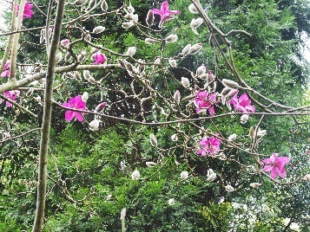
20th February 1981 | First flowers picked on Tin Garden ‘Diva’
20th February 2003 | First flower on Bishop Peter
21st February 1941 | Mag. sargentiana three flowers out. M. denudata showing colour.
21st February 1982 | First flowers seen on bank by steep step
21st February 1998 | campbellii properly out, also Auklandii, no flowers on ‘Bishop Peter’.
21st February 2016 | Magnolia ‘Caerhays Belle’ with one flower out  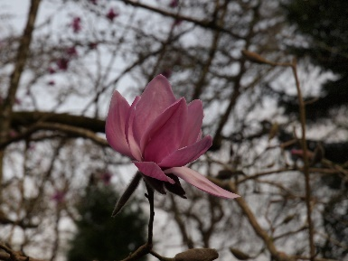
22nd February 1922 | Our Magnolia campbellii is very good indeed
22nd February 1976 | campbellii out above Crinodendron hedge
23rd February 1912 | Magnolia stellata shows white
23rd February 1961 | Flowers on campbellii and kobus
24th February 2002 | Flowers on M. stellata
25th February 2016 | Just time to catch a little sunlight late afternoon to bring you (again) the record tree 1913 planted Magnolia campbellii which is now full out and just starting to drop its petals (tepals). About a fortnight ago there were 100 or so flowers out, now there are thousands.  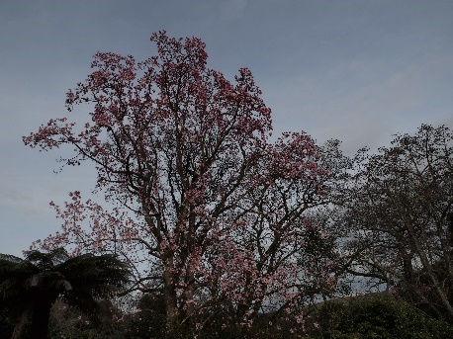
26th February 1950 | A few campbellii out
26th February 1966 | Picked two flowers of ‘Mr Gordon’ – no campbellii
27th February 1949 | campbellii at its best, several flowers on one mollicomata and two robustas as well as Diva and one out on dawsoniana.
28th February 1997 | First magnolia flowers out
29th February 1948 | Frost killed all flower on M. campbellii, dawsoniana and mollicomata. Over 90% of robusta but not sargentiana, Diva and salicifolia.
29th February 1995 | First flower open on magnolia close to steep steps
1st March 1958 | Donkey Shoe robusta full out and flowers on Michelia by Georges Hut
1st March 2019 | Magnolia ‘Caerhays Belle’ in all its glory about a month earlier than normal and quite possibly a record. The younger plants in the garden are already further advanced than this.
2nd March 1960 | First campbellii opened
2nd March 1961 | campbellii well open and Donkey Shoe robusta splendid
2nd March 2016 | Magnolia ‘Caerhays Belle’ is full out now.
4th March 1961 | soulangeana magnolias at Penvergate in flower
6th March 1950 | campbellii out, flowers on stellata, white campbellii shows colour.
8th March 1903 | Picked the first halleana (stellata)
8th March 1905 | halleana just out
9th March 1933 | First kobus bloom showing colour today
12th March 2000 | Magnolias at their peak – very good year indeed
14th March 1933 | Wilson’s big magnolia shows colour – wild ducks hatched

Surely this shows that the appearance of the first flowers in January or early February, which is perhaps seen as more normal in the last 10 or so years, is hardly new or a feature of climate change.

Just a few examples from the diary of the timing of the first snowdrops to flower here proves exactly the same point:

1st January 1897
1st January 1902
1st January 2019
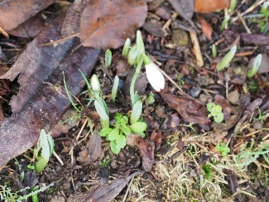
3rd January 1918
6th January 1998
7th January 1968
7th January 1900
8th January 1911
10th January 1971
10th January 2016
10th January 2020
11th January 1987
11th January 1993
11th January 2004
12th January 1964
13th January 1909
13th January 2017
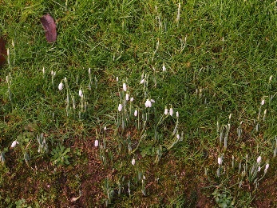
14th January 1989
15th January 1907
17th January 2018
18th January 1943
19th January 1968
20th January 1973
21st January 1921
21st January 1905
22nd January 1908
23rd January 1964
23rd January 1972
24th January 2004
25th January 1902
25th January 1899
26th January 1969
30th January 1900
1st February 1979
1st February 1997
5th February 1963
8th February 1904

Last autumn the newspapers were full of letters about snowdrops coming out in November in East Anglia and Northumberland. At Caerhays this year we first photographed a snowdrop in flower on 10th January. About normal despite ‘global warming’ as the diary entries show. Snowdrops were just as early into flower here before the First World War as they have been in more recent years.

In the 1970s the family children’s game was to collect as many (named) camellia flowers as could be found on Christmas Day. I well remember this being nearly 100 yet, when I did a review on 25th December 2019, I only got to about 40 and most of these were early flowering Camellia x williamsii varieties. Only a very few were forms of Camellia japonica.
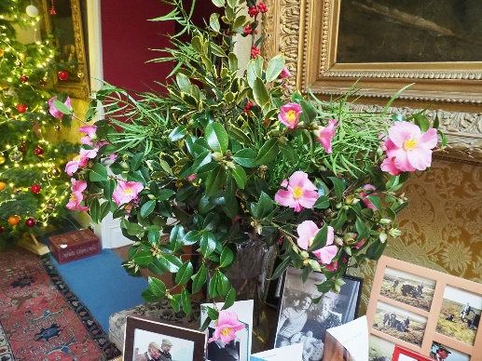
Camellias on Christmas Day

The diary entries are quite telling too but I am in danger of overwhelming you with too much information. The first flowerings of Camellia saluenensis, the early japonica camellia varieties and the x williamsii camellias varied by six to eight weeks over the last 100 years. Some early flowering years 80, 60 and 40 years ago are no earlier than they have been in the last decade of supposed warmth.

Camellia japonica ‘Lady Clare’ and Camellia japonica ‘Noblissima’ were planted together outside the front door after 1895 and the diary records their first flowers most years. ‘Lady Clare’ was out this year on 17th January 2020 which was after a very mild winter. It has been out much earlier over the decades.

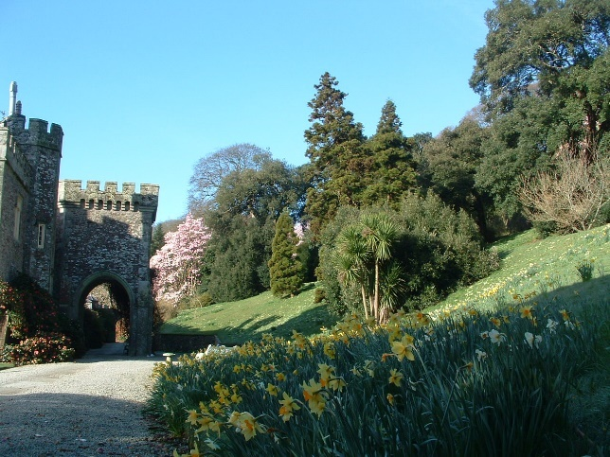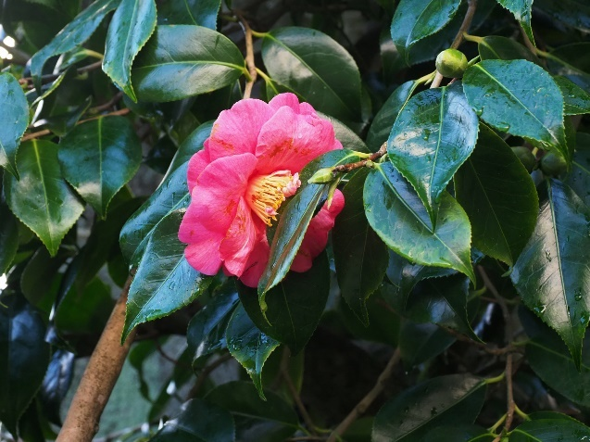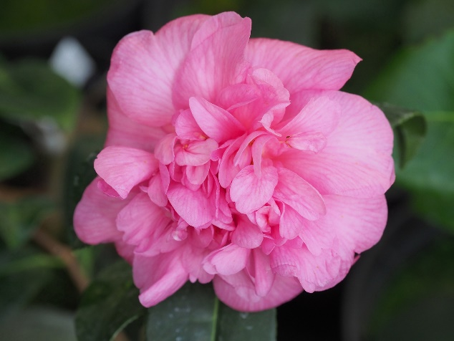
Caerhays Castle ‘Lady Clare’ Camellia x williamsii ‘Caerhays’

So what about the storm cataclysms in the history of the garden at Caerhays apart from the cold winters/springs of 1947 and 1963? What, if anything, has climate change or global warming got to do with these?

My family recorded the following disasters in the diary:

5th December 1929 | The worst wind smash in the New Planting we have ever known, in the big north end ⅓ to ½ of the conifers are uprooted and it will be long before we can clear it and see where we are. A further storm followed and brought more trees down in the Drive. We had about 14 inches of rain in the period of all Nov and 2 days of December. This rendered the trees weak in their roots.
From PDW December 1929 after the big gales | PS  I made out the macrocarpa is hopelessly brittle.  The Thuja a much better plant in that respect but not such good shelter.  Oaks hoist and break badly.  Beech stand well.  Grisselinia is about the best evergreen shelter, it anchors well is dense and flexible to the wind.  Insignis are not windproof under 50 years, when the wind seems to have less grip on their well rounded tops.  Laurels turn up their toes badly.  Chestnuts seem better than oaks.  Yews never notice it.  Ilex brittle and very hollow under.  Anceps bamboo very useful for this outside undergrowth.  Drimys winteri stood well, being tightly anchored when 25 years old.
16th January 1973 | Heaviest gale it is said since 1928 – climax of a very rough fortnight – tree damage considerable – three on drive alone
18th February 1978 | Worst gale of century so far. Auklandii Garden nearly flattened.
Winter 1977/1978 | Winter started mild but wet. Then on Feb 18 came the blizzard in Devon and the start of a month of gales at Caerhays. Feb 18th was the worst day.  1. Auklandii Garden: 2 Turkey oaks, 1 Abies, 1 Oak, 1 Plagianthus betulinus, (knocked down Mag hypoluca, tripetella, 2 soulangeana, + auklandii.  2. 5 Beeches, Ashes etc in Rookery.  3. Ash by Rookery Gate.  4. Big Insignis near Rookery Gate – knocked out R Cuneatum.  5. Beech above Veitchii + 3 poplars (Retic seedlings)  6. Crassum and Bo Peep nearly blown out of ground.  7. Slip Rail Insignis + Oak (this happened in March) knocked down Mrs Butler and shaved white Campbellii.  8. Beech below path.  9. 4-5 Elms by Rogers Quarry.  10. Big Fir by Tin Garden (knocked down best Salicifolia)  11. Tall Oak shaved best Delavayi group.  12. Q laurifolius in Ririei Opening.  13. 1 Insignis near Bramble Field Gate (earlier than Feb 18).  14. Big Beech, just missed Higher Quarry Nursery.  15. Small Fern Quarry enveloped by a Beech and 1 other.  Damage very considerable – Thank goodness for Power Driven Saws.
15th December 1979 | A very bad storm (wind 120mph). Burncoose a disaster area with the centre of the Drive flattened. Many trees down here. No electric for 36 hours.
25th February 1987 | The January Cold Spell and The Garden  The icy blast from the east which bit Caerhays for 3 days in early January may have done as much damage as any similar period in my time here. We have had long cold spells (1963). Blizzards and cold in the 70s when the plants in the 40 Acres were destroyed with few exceptions. And the Beech Walk lost half the plants.  The question of frost is puzzling as its effects are so odd and unpredictable.  Some plants, hurt badly in previous years, seem to be untouched.  Walks around the garden become increasingly bad affairs – I had hoped that a wet spell in February might have revived them.  Plants Looking Bad Everywhere  Michelia doltsopa  Rho. grande  Rho. sinogrande  Notofagus menzeseii  Rho. arboreum and hybrids (in many places)  Q. lamellosa  Lithocarpus pachyphylla  Castanopsis  Camellia Prof. Tsai  Partly Blasted  Rho. crassum (1 plant in clump of 3)  Rho. keyseii (1 plant in clump)  Rho. Michaels Pride  Saffron Queen  burmanicum x cubittii  But these are plants which in previous years were blasted – this time escaped  The Wall Mag. delavayi  Podocarpus salignum  Ordinary myrtles  Rho. arboreum – Cornish Scarlet  Killed to the ground in the 70s  Drimys winteri (touched)  The yew trees (blasted 3 years ago)  The Quercus ilex  Notofagus dombeyii  Last time the ice chill hit around the house. This time the chill was at its most severe in the Rookery. But the main damage came from the frost at the top of the wood (or in its heart) around Georges Hut.  If winters had been usually so severe in the years before 1947 how did the plants achieve their present size? The small and young plants in the whole fared better.  FJW
Hurricane of January 25th 1990 | Blew out (all Record sized trees)  1 Nothofagus obliqua  2 Nothofagus menzeseii  2 Nothofagus procera  1 Nothofagus solandrii  1 Nothofagus antarctica  ½ Nothofagus cliffortioidesBig group Eucryphia cordifolia  Eucryphia nymansensis  Magnolia salicifolia  Abies nordmanniiAcer henryi Knocked out of shape  Tetracentron sinensis “ “Acer franchettii  Magnolia highdownensis  Sasafras  Magnolia hypoleuca  Acer cappadocicum  Etc, etc

The great storm of October 1987 which so devastated Sussex and Kent gardens missed Cornwall although it woke us all up in the night as it passed up the Channel.

The worst disaster that the garden has ever faced (at least in my lifetime so far) was on 25th January 1990 when a hurricane struck Cornwall at about 9am. Around 20% of the garden was completely flattened and had to be cleared with machinery over the following two years with grants from English Heritage. One-hundred-forty-seven separate insurance claims were made on estate buildings.
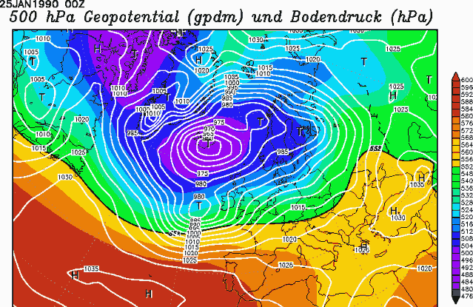

Again my father recorded the event before flying to Australia on a lecture tour.
1990 – TERRIBLE STORM, very bad for the garden. Storm of January 25th 1990

The storms of last winter (Chiara, Dennis and Jorge to mention only a few) brought down a number of mature trees but were not in the same category. The Garden Diary records similar very much more minor disasters such as the one above the drive in 1948 when several acres of shelter belt were felled in one go.
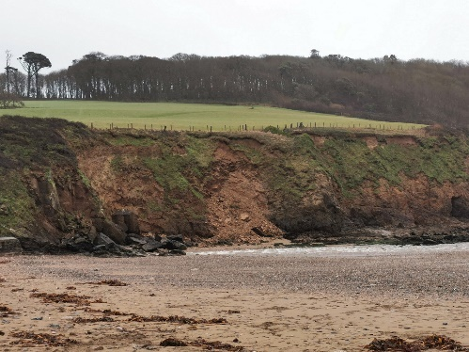
Storm Dennis or Ciara have caused a significant landslide or rock fall at Porthluney Beach.

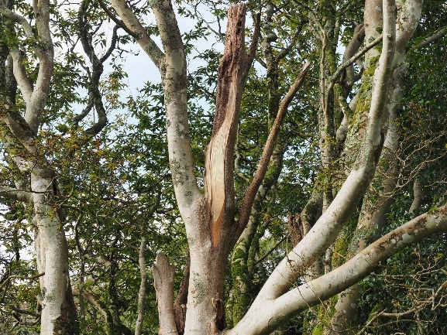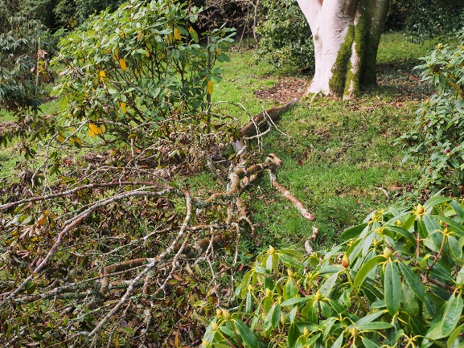
A branch blown off high up one of the elderly Magnolia salicifolias. Lots of minor mess like this to clear up after the storms.

While I can find no evidence of what we might term today as ‘hurricanes’ before 1990 in the diary Caerhays had its fair share of storm events in the 1920s when everything in the garden was much younger.

Are the recent winter storms (or gales as they used to be called in local parlance) any indication of the worsening of the weather? Or are they merely a feature of the current media approach which worships victimisation and must always apportion blame somewhere for what are just regular natural events?

There are other arguments on the subject of climate change which concern the plants themselves.

Quite often plants will anticipate a cold weather event and hold off flowering precipitously until the event has passed. One could call this seasonal adaptation. 2020 saw the third very mild winter in a row here but, this year, the magnolias held off flowering in January probably because they anticipated a coldish snap coming at the end of the month. One could argue that since it rained nearly every day in January until the end of the month that they were in no rush; but it amounts to the same end result. The diary records many years where the early magnolias were spoilt by frost or snow but it is less clear as to when delayed flowering was in their best interests. Certainly the magnolias got it very wrong in March 2018 and, similarly in 2012, as they had often before, but each season is different, and the plants do react to their circumstances current and future.

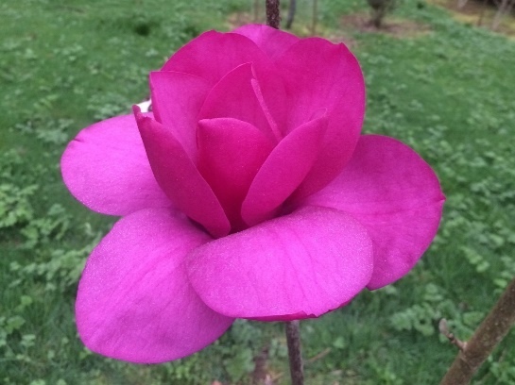

Magnolia ‘Black Tulip’ x ‘J C Williams’ - March 2018

Exactly as they do after dry summers when the threats of drought encourage procreation from more intense flowering in the following season. This is remarked on in the diary especially as regards magnolias and rhododendrons but, also, Chinese evergreen oaks which seldom seed or produce acorns in our Cornish climate except after a ‘dry’ summer.

Gardeners and farmers have always moaned about the weather. Now everyone moans about a climate catastrophe. We are led to believe that our climate is changing dramatically, and perhaps it will, over time. A hundred years of history in the Garden Diary however tells us that extremes of weather, whether as mild or cold winters, are irregular and occasional events which sometimes come in batches of similar seasons. Going further back into history, sea levels were much higher here 800 to 1,000 years ago, and the mid-19th century had colder winters than anything we have faced in the 20th century. These are clearly much larger scale variations in climate than anything seen in the last hundred years. After all, the ice age ended with global warming!
Melting glacier

Are we really convinced of ‘climate change’ on the basis of the perhaps somewhat anecdotal evidence put forward here? How can we ignore when the annual rainfall figures so clearly demonstrate no real change in the overall rainfall averages? All bad weather, named storms, and natural disasters, such as the recent flooding in Wales and northern England, are hyped in the media (and by those with other vested interests) as being part of climate change. Australian and Californian fires are also all part of this new ‘catastrophe’ thinking which we all lap up as the truth. The real reasons for Australian bushfires may well have more to do with lack of ongoing habitat management and routine natural fires being put out in recent decades.
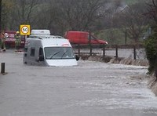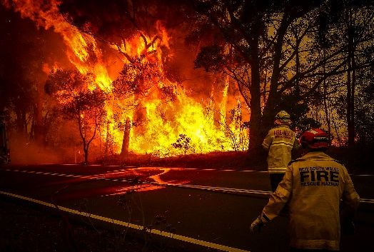
Flooding in Wales Australian bushfires

The recent history of the climate, in our little corner of Cornwall, tells a more common sense and credible story without the hysteria. The truth of ‘history’, as it has usually been taught to historians, has always been more about continuity over time, rather than instances of radical change. Why should climate be any different? Our climate may change but it might also revert to the accepted variable norm with devastating storms, deluges of rain, extreme cold and the occasional drought. Gardening has always been like this!

If putting my head over the parapet as a rational climate change denier results in a social media storm of outrage I will not bother to reply to anyone who cannot produce similar historical or at least anecdotal horticultural evidence to refute the arguments outlined here. If they can I will relish the plant based argument.

CHW
2.3.20

