Group Booking Application Form 2027

Please complete this form and return to groupbookings@caerhays.co.uk

2027 GROUP BOOKING ADMISSION RATES

Ticket | Adult Price | Yes/No
Garden Admission | £11.50
Garden Admission And Guided Castle Tour | £24.00
Guided Garden Tour with Head or Assistant Head Gardener (up to 25 persons) | £250.00 plus garden admission per person
Guided Garden Tour with owner, Charles Williams (up to 25 persons) | £300.00 plus garden admission per person
Hire of buggy and one of the gardening team for group tour (accommodates up to 3 people) | £75 per hire

Name of group

Date of visit

Group numbers

Invoice address

Name of group contact

Telephone number

Email
GROUP INFORMATION

DETAILS OF YOUR VISIT

Arrival time

Departure time

Magnolia tearoom - if you would like to reserve tables and pre-book lunch in our tearoom, please contact us for menus and further information.

Lunch in the castle – if you would like to enjoy lunch in the castle, please contact us for menus and further information.

Castle Tour | YES Time (please circle) 11:30 13:00 14:30 | NO

Tours are by guide only and last around 1 hour. Please arrive at the castle at least 15 minutes before your tour starts. Castle tours are available weekdays only, however we can cater for occasional weekends.

Groups larger than 20 PAX will be split into two, to ensure the best experience for our visitors.

Tours are subject to availability.

Garden Tour | YES | NO | Start Time

Guided Garden Tour with Head or Assistant Head Gardener.

Guided Garden Tour with owner, Charles Williams.

Guided Garden tours are subject to availability.

Morning tour start times available between 8:30 – 10:30

Afternoon tour start times available between 13:00 – 14:30

Tours last around 2 hours.

Transport Arrangements - if you are travelling by car, please ensure we have all registration numbers prior to your visit. Any vehicles parking in the beach car park will need to be registered with the office to prevent parking fines being issued.

FURTHER INFORMATION

Payment
Once your booking is confirmed an invoice will be raised for your visit. We kindly ask that all payments are made in a single transaction at least one week in advance of your visit.
Group bookings are non-refundable.

Manor Made @ Magnolia Tearoom.
The tearooms are open daily between 10:00 – 16:30.

Please note that food is made to order. In order that visitors receive the best possible customer service we politely ask that you don’t visit the tearooms all at once, but in smaller parties. Pre-booking is welcomed to enable us to provide you with the best service.

Castle Catering
Bespoke castle catering is available. Please get in touch to discuss your requirements and request menus.

Garden Guide Books and Maps
Garden maps will be available free of charge on arrival.
Garden guides are available at the shop to purchase at £8.95 each. If your group would like to pre-order books for collection on arrival, we can offer these at a discounted price of £6.95 each. This will be added to your invoice.
These guides offer an in-depth exploration of the gardens, thoughtfully organised with each route presented in dedicated chapters. An essential companion for anyone with a passion for horticultural beauty.

Pre-order your copy of The Garden Guide at the discounted price of
£6.95 each

Quantity required:

These will be handed to you on arrival to Caerhays Castle & Gardens.
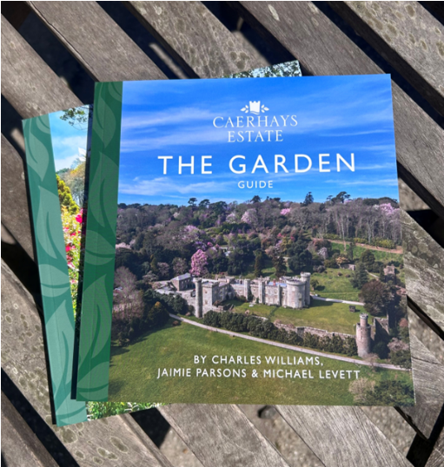

Coach Parking
Coaches are welcome to use our castle parking area – subject to availability. Please access the gardens by the double farm gates. If parking at the castle is not available then coaches will be asked to park at the beach car park.

For coach directions please see our website: https://visit.caerhays.co.uk/visit-us/directions/access-by-coach/ however we do strongly recommend the coach driver/representative speaks to us prior to your visit for directions and advice. Please
call the office on 01872 501310.

Disabled and Elderly information

It is important to note that the gardens are situated in a valley and therefore can be steep in some areas. Please ensure you have spoken to us if you are in any doubt about the terrain.

Please refer to the link on our website for further information.
https://visit.caerhays.co.uk/visit-us/health-and-safety/#elderly

Please do not hesitate to contact us with any specific concerns.
We are here to help.

